Spring 2026 Flower Sale
Just in time for Mother’s Day
ORDERS MUST BE RECEIVED NO LATER THAN APRIL 15, 2026

10” HANGING BASKETS
$16.00 EACH
CHOOSE TYPE, COLOR, AND QUANTITY

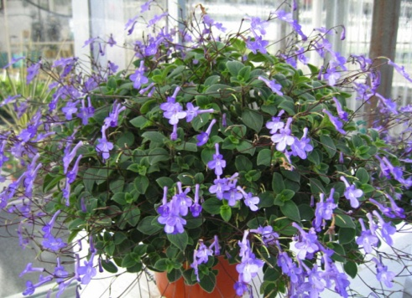

*BEGONIA – ASSORTED _____
*FUCHSIA – LILAC/RED _____
PINK _____
RED/WHITE _____
*IMPATIENS – ORANGE _____
PINK _____
PURPLE _____
RED _____
WHITE _____
GROWERS CHOICE _____
*VINCA CASCADE – MIX _____
*GERANIUM VINING –
BLUE _____
PINK _____
RED _____
*PORTULACA – MIX _____
*TORENIA – BLUE _____
*VINING VIOLET –
PURPLE _____
*PETUNIA – BLANKET – MIDNIGHT ____
ROSE STAR ____
VIOLET ______
ZINFANDEL _____

12” COMBINATION PLANTERS
$30.00 EACH OR
$27 FOR MORE THAN 1
(ONLY APPLIES TO COMBO PLANTERS)
CHOOSE Sun/Shade and QUANTITY

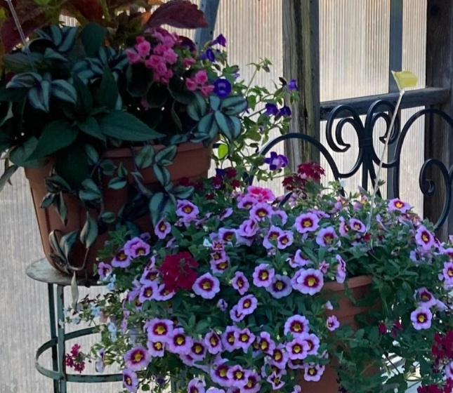

12” ROUND PATIO POTS
SUN _____
SHADE _____

**THERE IS NO FLOWER VARIETY OR COLOR CHOICE FOR THIS ITEM
EACH POT IS A MIXED VARIETY BY AVAILABILITY.

PICKUP IS REQUIRED. NO DELIVERY AVAILABLE.
PICKUP WILL BE AT THE SHRINE
1877 Shriners Way, Cheswick, PA
SAT, MAY 2, 2026, 12-3 pm

Make Check Payable to: Airys No. 48

Mail BOTH ORDER FORM AND CHECK TO: JOANNE DILLER
1109 DALLAS AVENUE
NATRONA HEIGHTS, PA 15065
724-224-9496
NAME ____________________________
ADDRESS _________________________
CITY/ZIP CODE _______ PHONE______________
TOTAL $ ENCLOSED WITH ORDER $_________

ALL PROCEEDS BENEFIT AIRYS TEMPLE, DAUGHTERS OF THE NILE AND ARE NOT TAX DEDUCTIBLE

